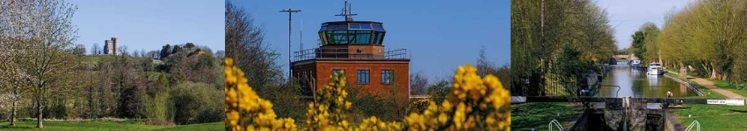

Parish Council Report for August 2020

Cllr Dominic Boeck

Aldermaston Ward

West Berkshire Council

Council Meetings
August is a quiet month for public meetings but this does not halt preparation for both Executive and Council following the return from summer breaks in September.
On 3 September the Executive received a number of papers on Council performance for Quarter 1 and agreed for the London Road Industrial Area draft development brief to be published.
On 10 September full Council will consider the White Paper for Planning.
Links to all agendas etc are at http://decisionmaking.westberks.gov.uk.
All WBC public meetings are broadcast live on YouTube and recorded so that they can be viewed at leisure - West Berkshire Council YouTube Channel
Over the coming few weeks we shall also be reviewing how we move forward with virtual meetings.

Covid-19

Recovery Strategy
As was mentioned last month, but is worth repeating, the Recovery Strategy is structured around three core elements; health, education and the local economy.
The council also published its Recovery Action Plan as an appendix to the Strategy - West Berkshire Council Recovery Strategy.

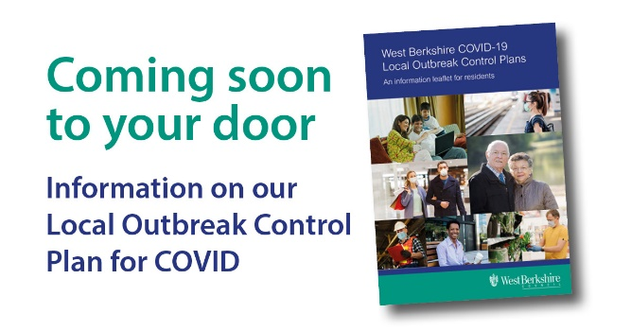
Local outbreak control planning
The Council is currently distributing an information leaflet on the Local Outbreak Control Plan.
The leaflet explains how we will aim to protect residents and communities by minimising further spread or recurrence of Covid-19 across West Berkshire.
A copy of the leaflet can be downloaded Information leaflet on LOCP

Council Plans

Digital Strategy
WBC has formally launched its new Digital Strategy 2020 – 2023 to further improve service delivery and pave the way for 5G, ultrafast broadband and full fibre connectivity across the district.
Under the three year plan, the Council will implement new digital technologies and processes to make it easier for residents to access Council services online and keep them better informed, and for staff to work more efficiently. The Digital Strategy will also harness the benefits of the more digital working environment that was accelerated by the UK Covid-19 outbreak.
The Digital Strategy also will help drive development of a modern ‘Digital District’ that features 5G mobile phone coverage, ultrafast broadband, full fibre connectivity including more public Wi-Fi spots, and electric vehicle charging points. The strategy will foster partnerships to implement these latest digital technologies throughout West Berkshire for the benefit of residents, businesses and visitors.
WBC will play an active role in ensuring that those who live and work in the district are able to improve their digital skills, as well as implementing measures to avoid digital exclusion. These actions include making digital transactions simpler and easier to understand, commissioning training opportunities, and providing IT equipment to public facilities.

Environment

West Berkshire Community Climate Bond
The Community Municipal Investment remains open until 16 September so there is still opportunity for those who have not yet done so to invest if they wish. The Bond which aims to raise £1m for photovoltaic panel installation has currently reached £600,000.
Investments start from £5 and will earn a return of 1.2 percent over a five year term, with capital returned in instalments across the investment term.
Further information can be found at https://info.westberks.gov.uk/wbcmi

Adult Social Care

Resource Centres
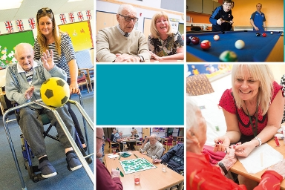
Having been closed due to Covid-19, we were able to reopen Resource Centres on Monday 24 August in accordance with government guidelines.
The Resource Centres at Hungerford, Newbury and Calcot provide a wide range of services to help adults with learning disabilities, physical disabilities and people with frailty and dementia.

Residential and Nursing Care Placements for Older People Policy
Following consultation, we have recently published a revised Policy clarifying how we deal with care home (etc) placements for those entitled to our support.

Walnut Close Care Home (Thatcham)
We are in the process of consulting residents, their families, our staff and other interested parties about the future of this care home.

Education

A Level and GCSE Grades

Individual stories about A level students who did not get the grades they expected have been well documented in the media. Schools and colleges will have been supporting students for whom this has been the case before A level grades were re-awarded using teacher assessment. That said, A level students have received the highest grade they were able to get in the absence of actually sitting the exam.

The award of the teacher assessed GCSE results on the day rather than retrospectively has meant slightly less worry for students. However, the additional workload to prepare for the day with such a late change to the system will have impacted on schools and colleges. The longer term impacts (such as Higher Education entry) are unknown.

We continue to track the participation status of all school and college leavers, offering advice and guidance to those young people who need it. As with previous years, we will be making an Annual Activity Survey return to the Department for Education in October, which will provide us with a comprehensive picture of local education, employment and training participation, and those young people who may have had their plans changed due to the unprecedented circumstances.

Home to School Transport
The Home to School transport team has issued update guidance on the arrangements in place for September - https://info.westberks.gov.uk/article/37434.
In England you must wear a face covering by law on public transport (and in some other public places) with some exemptions. Advice on face coverings has been issued by WBC.

Culture and Leisure

Reopening of pools
Six leisure centres opened from Saturday 25 July following changes to the social distancing guidance. At that stage only fitness gym and selected classes became available so that centres can get used to the new arrangements and make any adjustments required to ensure safety.
We now anticipate that leisure pools will be reopening following essential water quality checks and necessary adaptations to ensure staff and swimmers are adequately socially distanced.

Waste Services

Garden Waste Collection
Subscriptions for the 2020/21 garden waste service are open - the subscription period runs from 1 September 2020 to 27 August 2021. The subscription fees remain the same as last year, with the service charge for the first bin costing £50.
A reminder email or letter is being sent out to all current subscribers inviting them to renew their existing subscription online at www.westberks.gov.uk/gardenwaste.

Transport and Countryside

Reopening of Northbrook Street
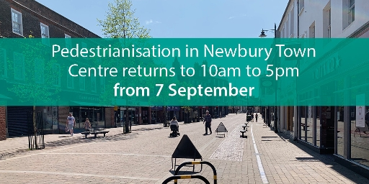
Having been introduced as part of a part of a range of measures to support the local economy as shops began to reopen in June, the temporary measure to make Newbury Town Centre pedestrianised 24 hours a day will come to an end on 7 September. Times for the town centre pedestrianised zone will then revert back to 10am to 5pm to ease pressure on local roads with the anticipated increase in traffic from the return to schools.
It helped to support outdoor eating space and provide a boost to shopper's confidence to return to the high street by ensuring that West Berkshire was safely open for business.

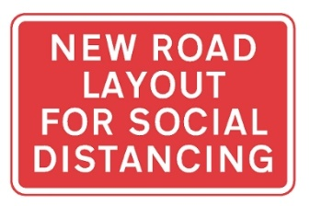
Active Travel Fund - changes to road layouts and new infrastructure to encourage active travel
West Berkshire Council has been awarded £124k by the Department for Transport to help introduce pop-up and temporary interventions to support and create an environment that is safe for both walking and cycling.
One of the few positive aspects to come out of the Covid-19 crisis appears to be that people are exercising more often and there has been a higher uptake of active travel as people have discovered, or rediscovered, cycling and walking. In some places, there's been a reported 70% rise in the number of people on bikes - for exercise, or for safe, socially distanced travel.
The allocation is part of the government's emergency active travel fund and indicates what we will receive under two phases. Under phase one, we will focus our efforts on measures that encourage active travel and can be implemented quickly to provide additional road-space for walking and cycling. These schemes need to be implemented within eight weeks to be eligible to receive the funding.
Measures include:
- additional cycle parking in a number of our towns and villages;
- temporary road closures and parking suspensions to enable social distancing in town centres;
- temporary exemption for cyclists in one way streets;
- widening of footways at busy locations for example at bus stops;
- permanent conversions of temporary cycle ways;
- pop-up cycling facilities and conversion of advisory cycle lanes (broken white line) to mandatory cycle lanes (marked by a solid white line which vehicles are not allowed to enter except in an emergency).
Phase two will be released later in the summer to enable us to secure funding of £495k towards more permanent measures to encourage active travel.
We always welcome feedback from our residents so if you have any suggestions to improve active travel in your area please contact trafficandroadsafety@westberks.gov.uk.

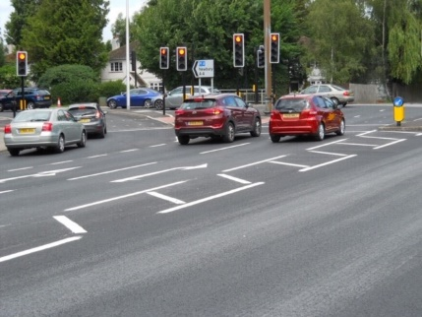
LED Traffic Lights
The upgrading of 17 sets of traffic lights to become more energy efficient as part of the Council’s commitment to delivering a greener district continues.
The new LED bulbs last up to 15 years longer, saving 38,200 kWh of energy and 21 tonnes of carbon annually, and supporting the delivery of the Environment Strategy and the aim to achieve carbon neutrality by 2030.
West Berkshire has 86 traffic signal sites across the district, 46 of these are currently LED and the plan to up this to a total of 66 by the end of the year and to phase out ‘traditional’ light bulbs as soon as possible.

Support for local businesses and residents

Social Distancing
Whilst community transmission rates are comparatively low, as lockdown is eased and those in the shielded and vulnerable groups are able to leave their home (if they so wish) it is as important as ever that social distancing is observed – see the latest HMG advice.

Communications Channels
As well as Twitter there are also a number of Facebook pages which the Council uses, for example:
- West Berkshire Council;
- West Berkshire Community Support Hub Group;
- West Berkshire Libraries.
The WBC website also contains more about the CSH and useful information for residents and businesses:
Residents https://info.westberks.gov.uk/coronavirus-residents
Business https://info.westberks.gov.uk/coronavirus-business
Community hub https://info.westberks.gov.uk/coronavirus-communityhub
Linked to all of these initiatives is the WBC Customer Service telephone line: 01635 551111.

Annual Canvass of Electoral Register
The annual canvass is currently taking place so that West Berkshire Council can keep the electoral register up to date. People who have moved recently are particularly encouraged to look out for the voter registration messages from West Berkshire Council and check the details.
The structure of the annual canvass is changing this year and will allow some existing residents to receive email communications rather than the traditional paper forms. If occupants are required to respond, this can be done online, or in some circumstances by phone and text.
With Police and Crime Commissioner elections taking place in West Berkshire in May 2021, this is an important opportunity for residents to make sure they can take part. The easiest way to register is online at www.gov.uk/register-to-vote.

Other Matters

Royal Berkshire NHS Foundation Trust - a major modernisation of the entire estate
In autumn 2019 the Department of Health & Social Care announced a new Health Infrastructure Plan providing funding for 40 new hospital building projects over the next 10 years.
RBFT has been chosen to receive seed funding to develop a masterplan and compile a Strategic Outline Case (SOC) for the future development of a new hospital – this could be a completely new hospital or a combination of new build and refurbishment. All possibilities are to be considered including a new hospital on the Reading site and a new hospital on another site.
The SOC needs to be submitted to HMG later in 2020 – it won’t seek to determine the outcome, but will rather analyse population data from ONS, the outcome of engagement with local communities, and feedback from staff and clinicians. The intention is to produce a Long List of realistic possible solutions.
The next steps will be: further engagement with key stakeholders including staff and Governors, members and MPs, patients and the public, as well as local partners including health and care partners, local authorities, local businesses and Reading University.
For more, please go to the development microsite.

